**Diary Writing**

**Meet Sheladiya – 19BIT076**

**Assignment – 2**

**Relational Model**

Well, the concept of this assignment i.e., to make a relational model of our data set was new to us so we were quite excited to perform this with the participation of whole group. Again, as a team we divided our work and started working on it. We were asked to give 4*N tables therefore every member came up with 4 entities and their attributes, before finalising we had a group discussion on the entities provided by all the members to make the model unique and efficient. I worked upon **Payment method, card details, confirmation and audience temperature.** I made the tables with these entities and attributes and highlighted the respective Primary Key. We had a final discussion and the compilation was done along with the discussion and we also had a discussion over Foreign Key to relate the tables with each other. Finally, our Assignment 2 was completed and it was as it was supposed to be.

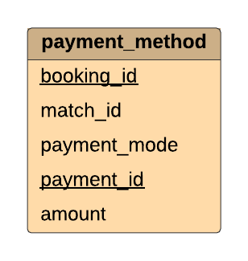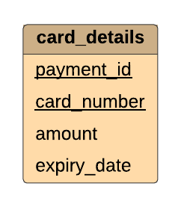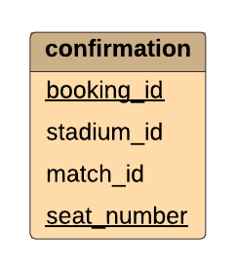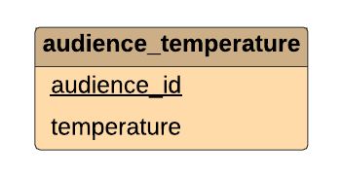

**Assignment – 3**

**ER Model**

This assignment was related to the previous one it was a complete team work as we were supposed to make the relations between the tables, like in my case the card details table was related to payment method and it was further related to confirmation after successful payment. The audience temperature was not related to above three therefore we made the relations of all the leftover tables through group discussion with all the members. And then a complete E-R model was made with the help of an online software – [Lucid chart](https://lucid.app/lucidchart/21c4d692-d021-4418-a7e8-7b0c9c5d97c6/edit?page=0_0)

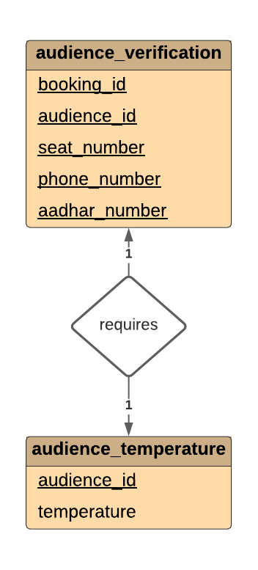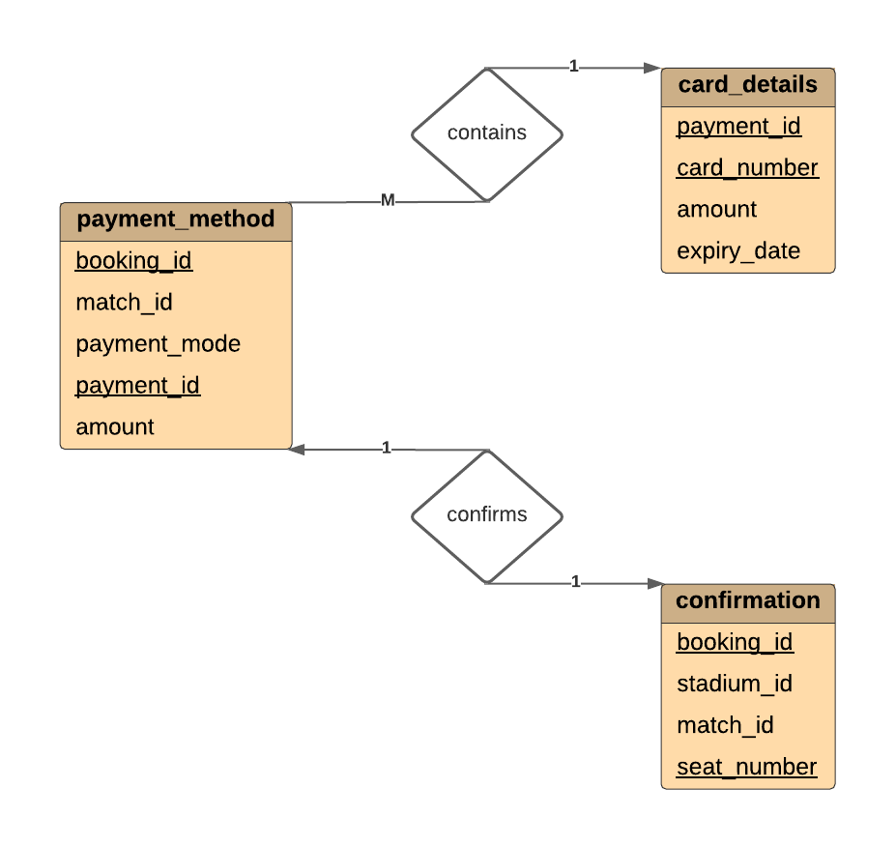

**Renish Jagani – 19BIT108**

**Assignment -2**

**Relational Model**

After our first assignment we got the second one and this time it was something which we never heard of before and everyone was little confused regarding the assignment 2, So we decided to have a discussion and then we discussed a lot amongst ourselves after taking the idea from our study material, Google and watched some YouTube Videos. After few discussions we got clarity of this particular Project, the task was to make a relational model of the data base system and there needs to be 4*N tables so the distribution work took place and everyone got their fields.

I made the table’s **fixtures, venue, home_ team, away_team.** Th**e** task was to make the table using these entities and attributes and underlined the Primary key of each table. The last task was to decide the foreign key to relate all the tables to each other. At the end after so much of discussion and hard work our second assignment was ready to upload.

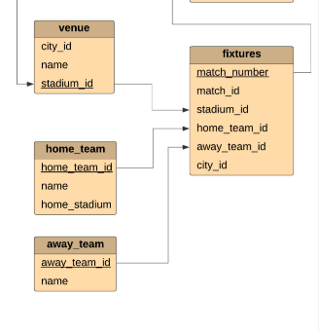

**Assignment – 3**

**ER Model**

After the second assignment the third one was co related to the second one, the task was to make out the relations between all the tables. Two out of four entities that I had were related the other two were not related so we had an online meet to relate the tables with the tables of other group members. We did a lot of discussions and worked out the things for a perfect model. We had a lot of contradictions but then after working out on them finally, the relations were made for all the tables and the task was done in an online platform.

Every group member played their role of completing the task on time, everyone helped each other in their doubts and confusions and this eventually increased our understanding and team spirit.

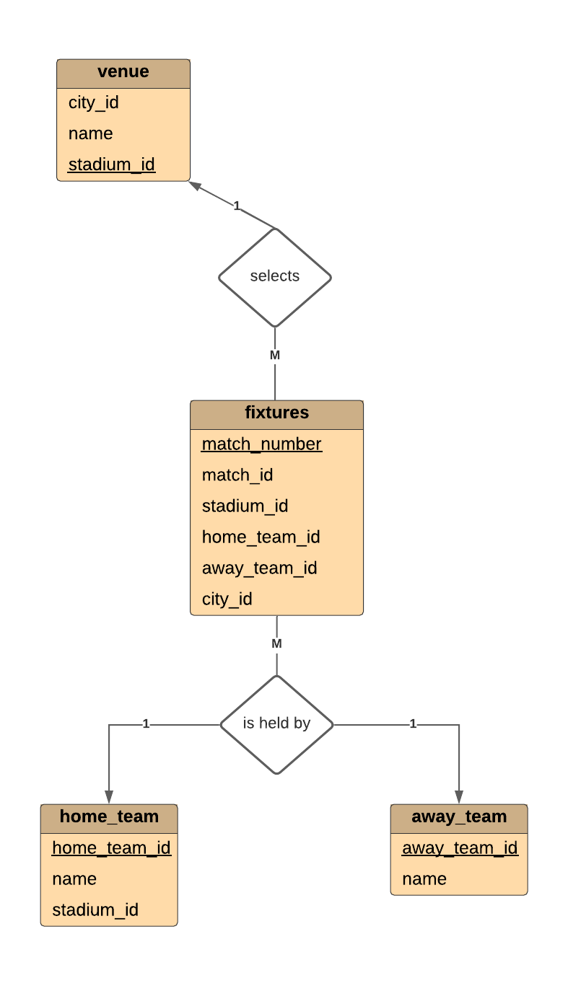

**Rishit Samariya – 19BIT109**

**Assignment-2**

**Relational Model**

This assignment was also a group assignment in which we have also develop group spirit and bonding. In this assignment every student have given idea of entity and there attribute we have called meeting in which every student have given 4 entity and there attribute to. If by chance it lead that there is common entity then we have solved that problem in group and it help us to figure it out. I am given the area to find entity and its attribute related food and beverage and jersey of team. So I have made the 4 table with their entity and attribute in which Primary key was underline.

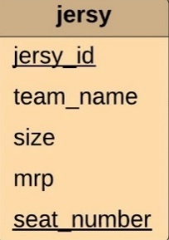 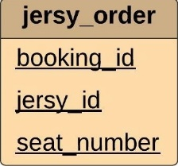 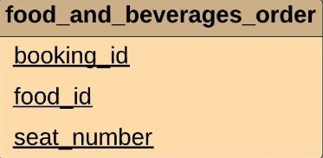 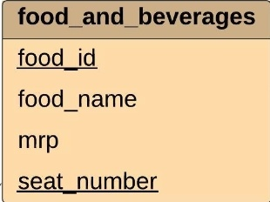

Then by gathering all detail by group member we have made the Relational model in group by giving the idea of foreign key To relate the table with each other. And we have finalise the Relatinal model in online platform.

**Assignment-3**

**E-R model**

This Assignment was based on assignment 2 which was Relational model after making of Relational model I have make relation between the tables which I have made to other. Between the jersey and jersey order there will be relation of order which will be denoted by diamond and entity will be denoted by rectangle. Same in Food and beverages and Food and its Food and Beverages order there will be same relation of order. And also given the relation between Seat Details Entity with Food and Beverages entity and Jersey entity the relation I have given was of view. Then we have given idea in Group and then we have made the diagram through online platform ([https://lucid.app/lucidchart/21c4d692-d021-4418-a7e8-7b0c9c5d97c6/edit?page=0_0#).](https://lucid.app/lucidchart/21c4d692-d021-4418-a7e8-7b0c9c5d97c6/edit?page=0_0%23).%20) Then I have also given 1 feature of Stadium which is listed in the PPT that we have made. This all work has been finalised in the PPT.

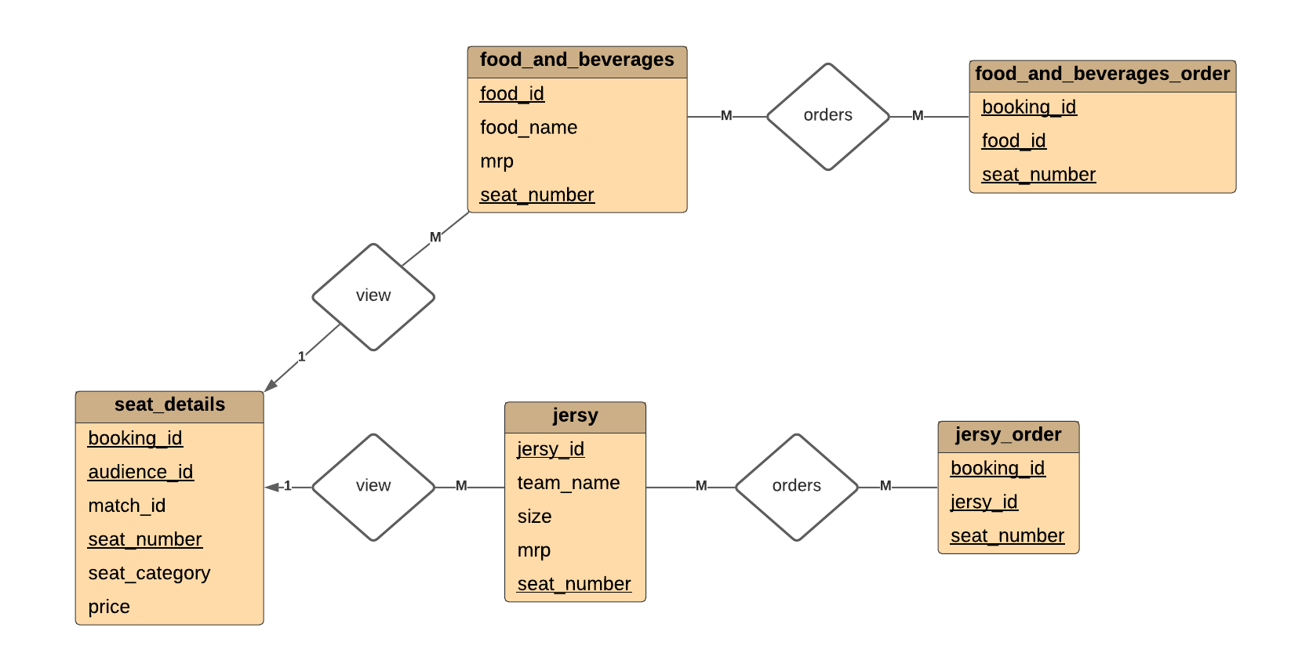

**Rishabh Patel - 19BIT141**

**Assignment – 2**

**Relational Model**

In the assignment – 2 we work on relational model where first I create my 4 input tables that are login table, seat booking table, seat location table, seat detail table and then we started making diagram in lucid chart where we first made rectangle tables for attributes and then we find super keys, primary key and foreign key. I underlined the attributes for primary key. Then I find relations between each of the four tables. By calling a meeting we solved the problems which occurs between each other input tables and came up with more relevant solution. Finally we evaluate each other work and merge the final work done by all team members.

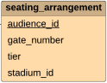 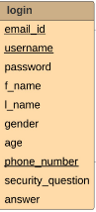 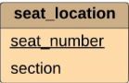 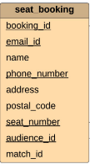 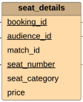

**Assignment – 3**

**ER Model**

The Assignment – 3 is Entity Relational modeI and because Relational model is simpler model of ER model and so it is very convenient of us. I made the relation sets between the assigned input tables and created the entity sets for the attributes and shown the symbols used in ER model and represents the aggregation through schema. For Instance login and seat booking has relation set of user registration shown that one user can book many seats for each match. Similarly for seat booking and seat detail there one-to-one relation because for each seat there can only be single data in seat detail. We initially created ER model in Visual paradigm but then we moved to lucid chart because it provides more feature and it is more user interactive. Then we finally evaluate our work and merge final output of all team members.

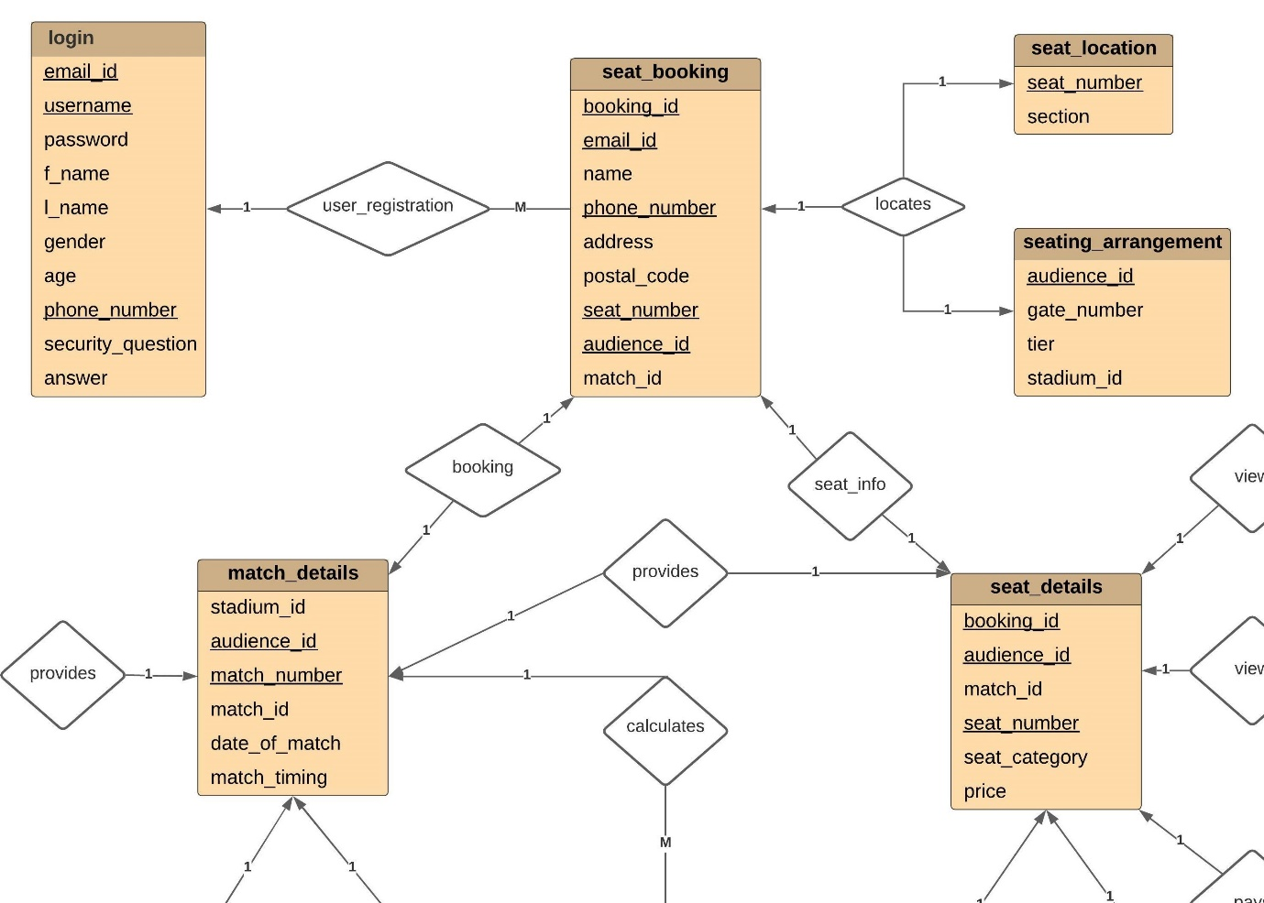

**Ujash Thakkar – 19BIT142**

**Assignment-2**

**Relational Model**

In This assignment every member creates 4 input table. And I create stadium_details, match_details, audience_verification and tickets_cancelled. In this relational model underlined attributes for primary key and every relational model has minimum at least one primary key. After creating 4 table I have to think about how all table are interrelated after the group discussion all doubt will be clear. After completing all the work by a group member that’s the time merge the final work.

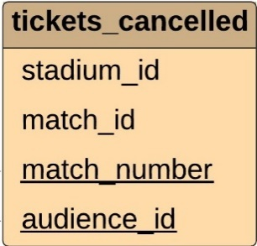 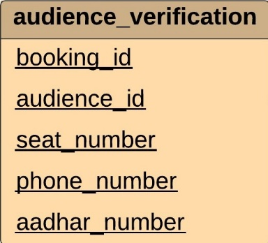 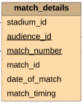 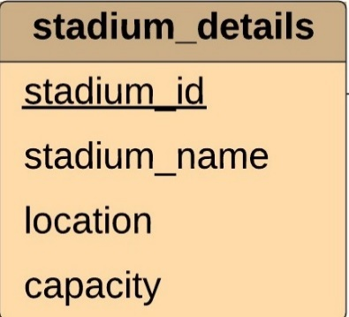

**Assignment-3**

**E-R model**

This Assignment was entity relationship model it’s quite easy because it based on assignment 2 which was Relational model after making of Relational model. After that I have to create relation sets between the assigned input tables and created the entity sets for the attributes. Between the stadium details and match details there will be relation of order which will be denoted by diamond that called by (provides) and entity will be denoted by rectangle. At the time when person was seat booking that time person see name of stadium and location of that and etc. The relationship between audience_verification and seat_details is verifies and the relationship between tickets_cancelled and seat_details is shows. Then we have given idea in Group and then we have made the diagram through online platform.

**Ananya Khandelwal – 19BIT144**

**Assignment – 2**

**Relational Model**

Our second Assignment was to make a relational model of our data base. This thing was new to us so we took some time to properly understand what a relational model is and how it is made we had a lot of group discussions about the relational model and when everyone was familiar with the model we began working in our respective provided field. We were supposed to make 4*N tables, so the four I worked upon were **tickets sold, advertisement, weather, tickets available.**  I was not clear about how to make the tables so I discussed with my group and we concluded that the table is to be made with these entities and attributes and the primary key is to be mentioned or highlighted so I made the tables accordingly. Then at last we had a discussion on foreign key to relate the tables with each other. After a lot of discussion and improvements the Assignment 2 came to an end and was made perfectly. Our understanding of the subject was quite better than before.

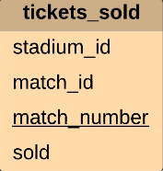 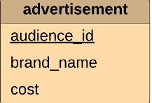 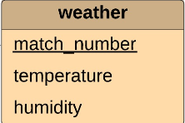 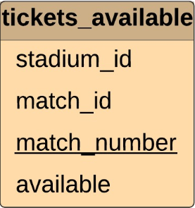

**Assignment – 3**

**E-R Model**

This assignment was just an upgrade of the previous one and it was completely a team work as we need to relate the tables with each other so we had arranged meetings accordingly and began the work of making the relations. Talking about my tables all the four were not related to each other therefore in our meetings we related each other’s table and came up with a proper ER Model and the model was created with the help of an online platform - [https://lucid.app/lucidchart/21c4d692-d021-4418-a7e8-7b0c9c5d97c6/edit?page=0_0#](https://lucid.app/lucidchart/21c4d692-d021-4418-a7e8-7b0c9c5d97c6/edit?page=0_0%23)

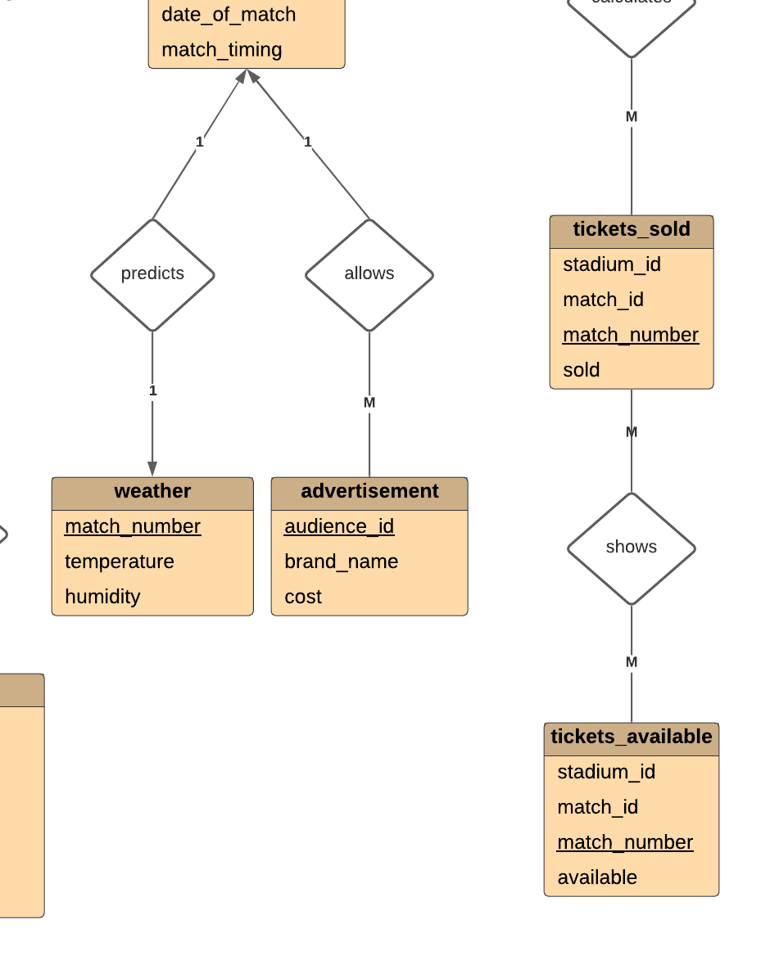

**Assignment – 5**

**Topic:- Installation of MySQL Relational Database Management System**

**Objective:-** To learn basics of MySQL software that can be used for SQL Query evaluations.



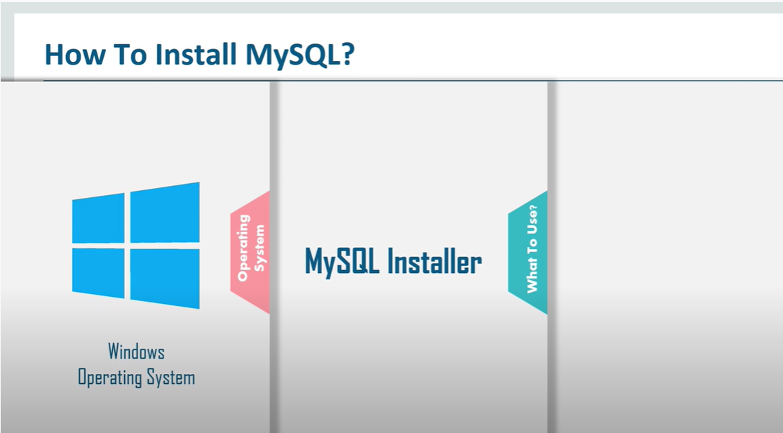

**Follow the Steps Below:-**

**STEP: - 1**

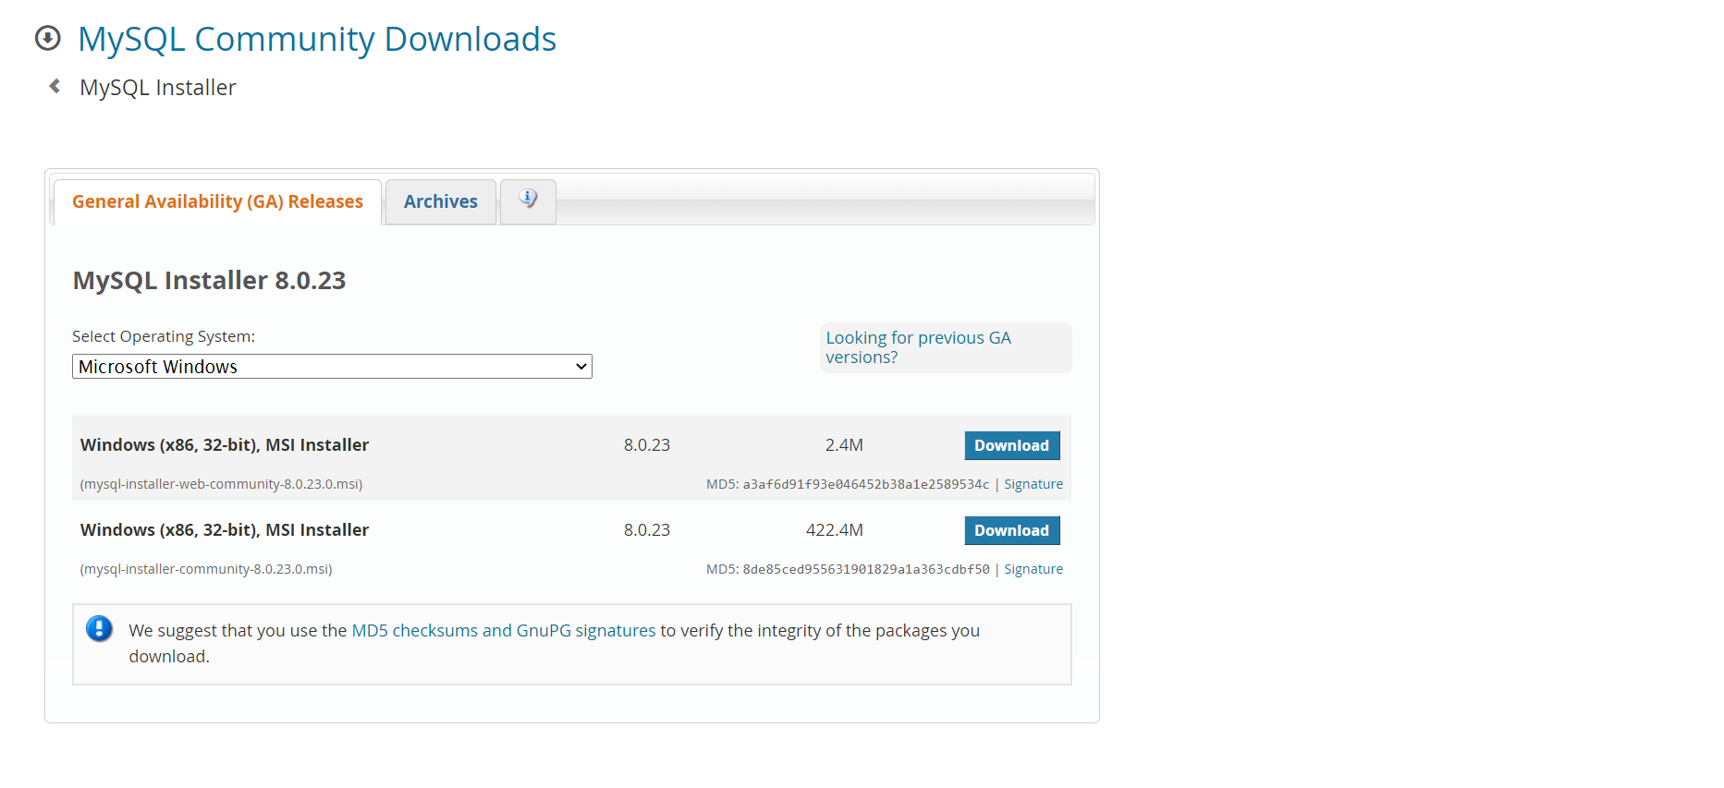

**STEP: - 2**

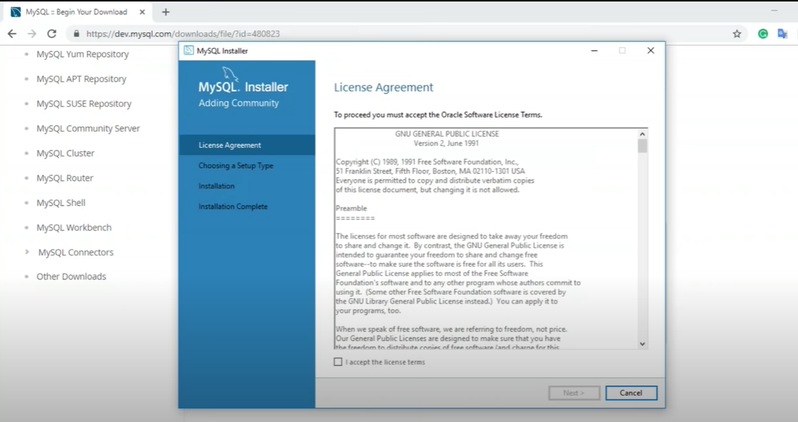

**STEP: - 3**

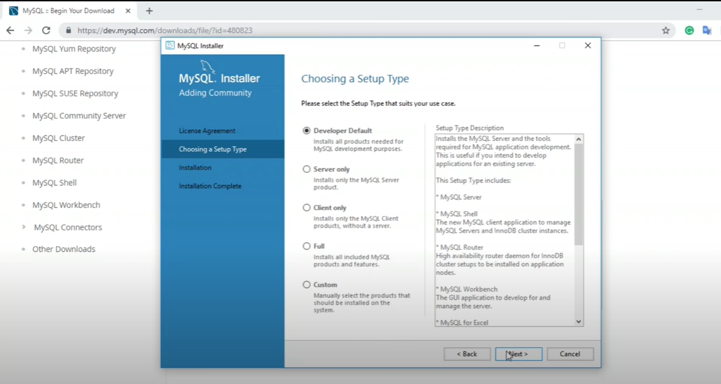

**STEP: - 4**

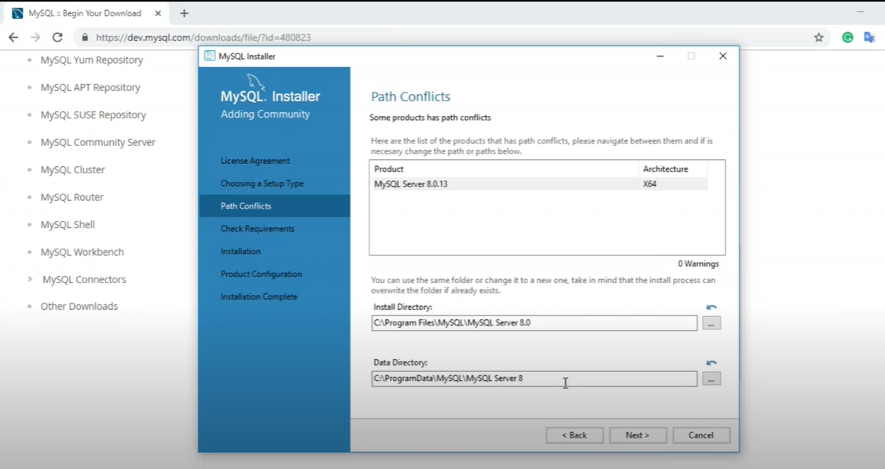

**STEP: - 5**

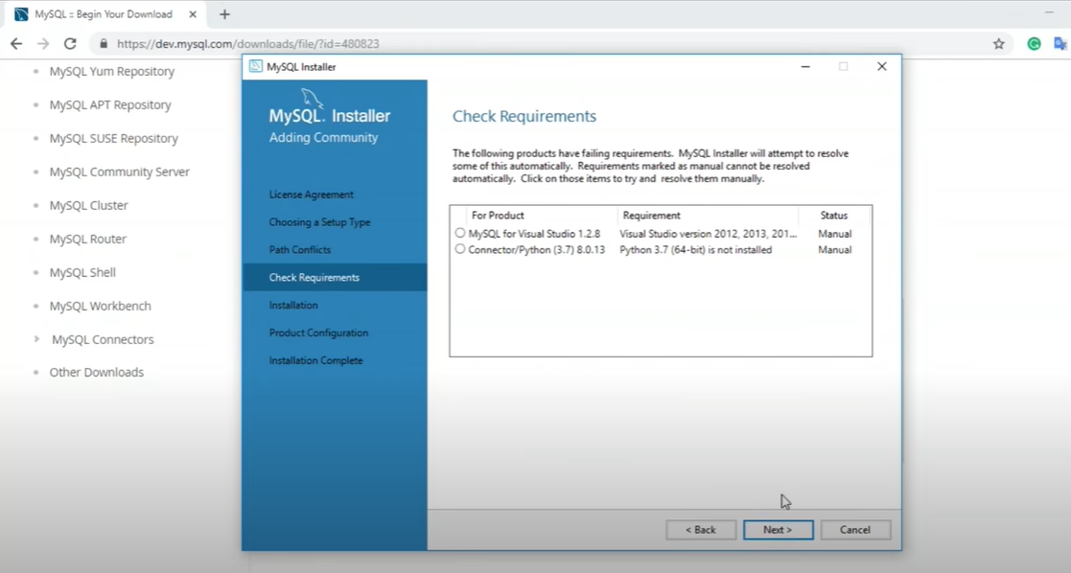

**STEP: - 6**

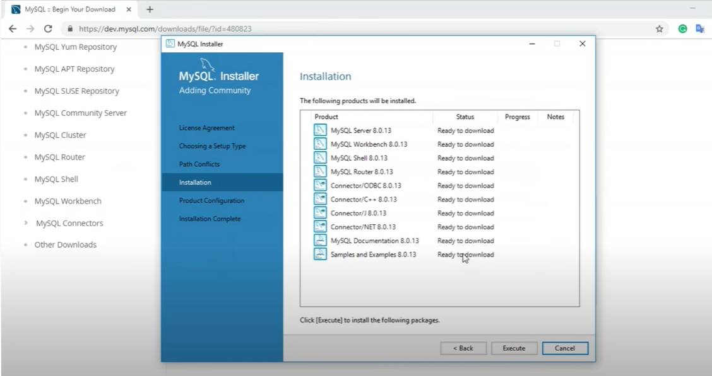

**STEP: - 7**

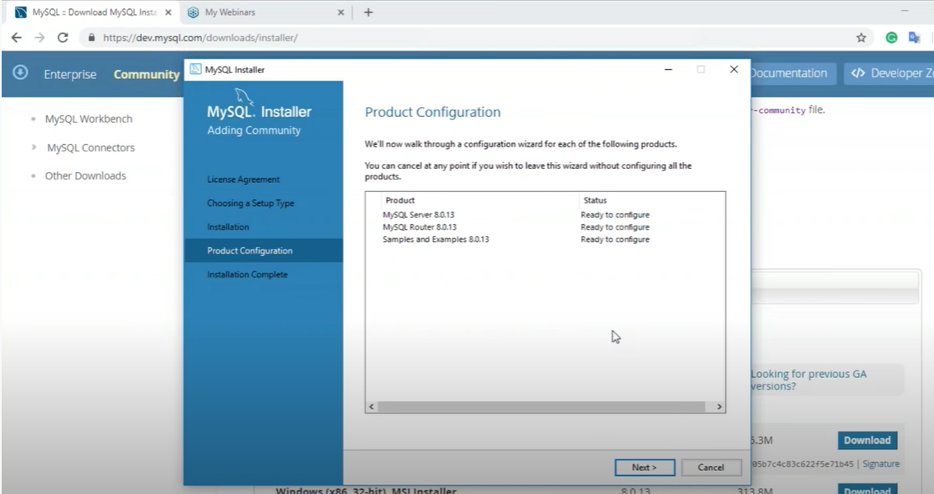

**STEP: - 8**

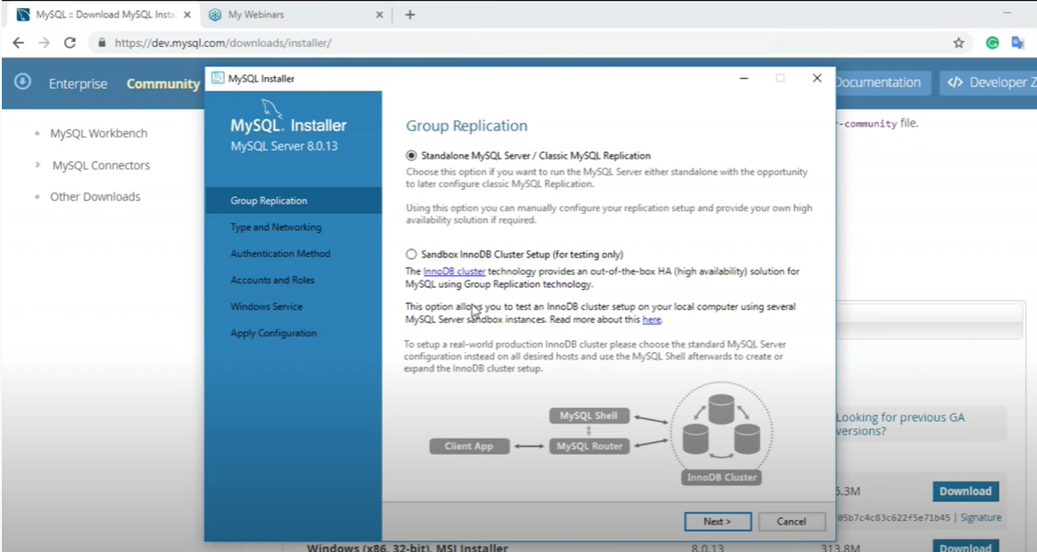

**STEP: - 9**

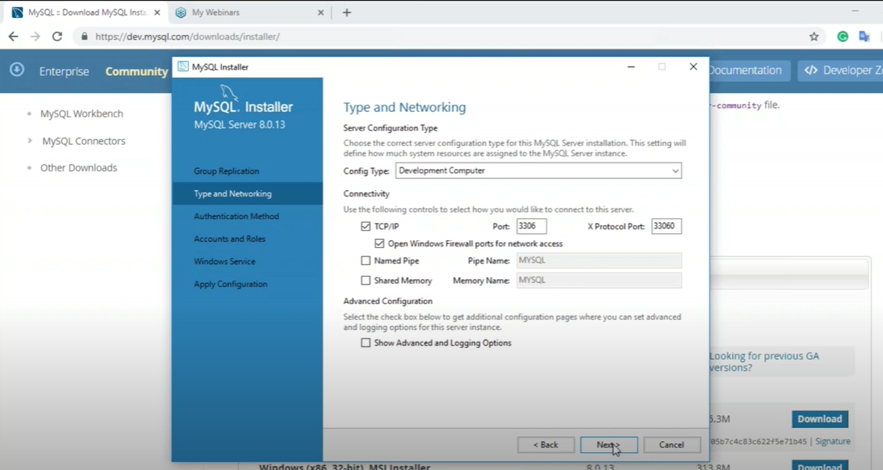

**STEP: - 10**

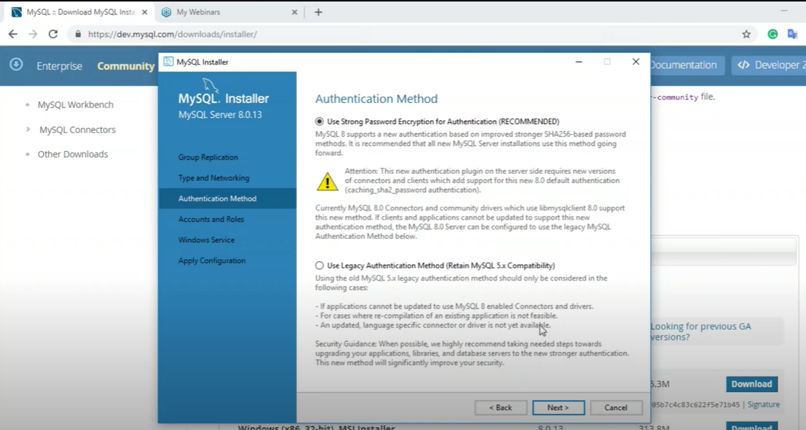

**STEP: - 11**

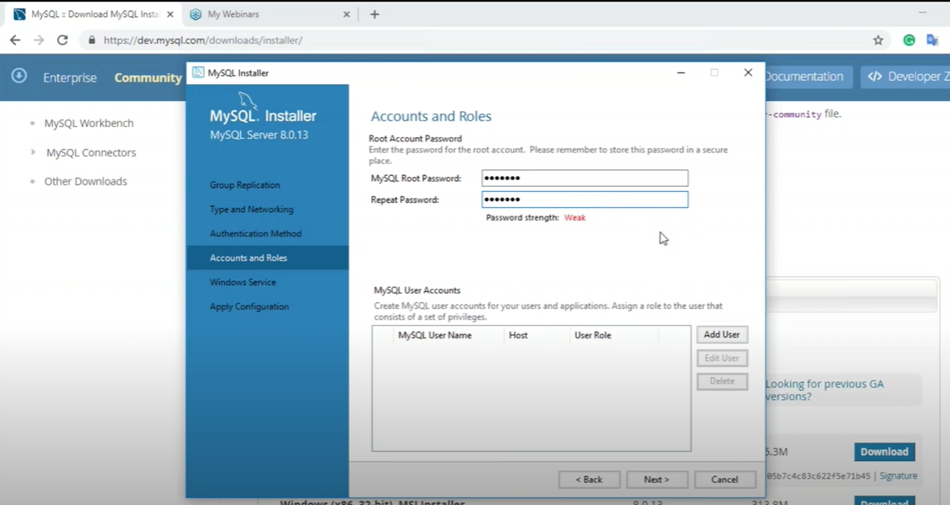

**STEP: - 12**

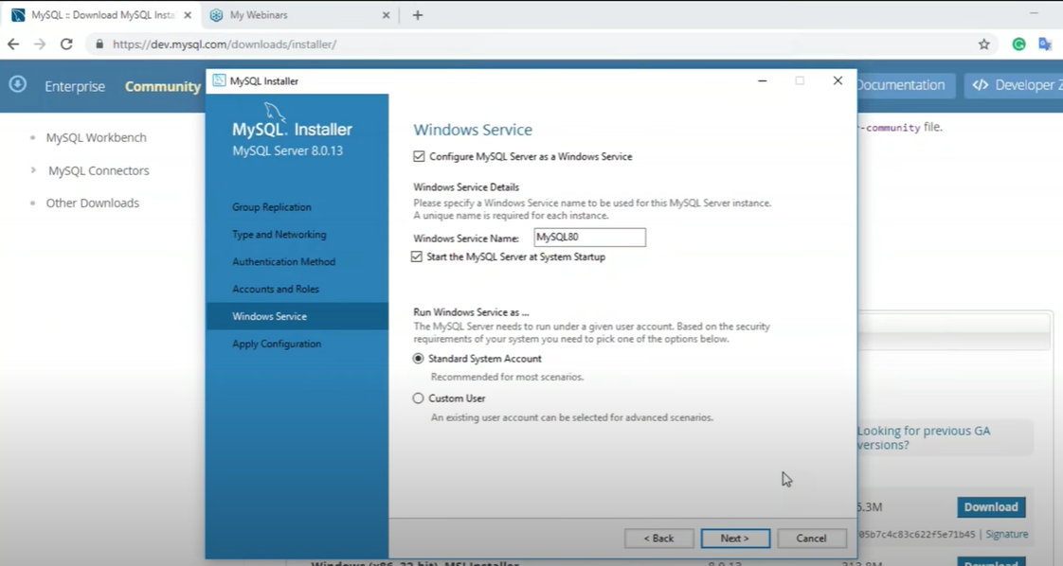

**STEP: - 13**



**STEP: - 14**

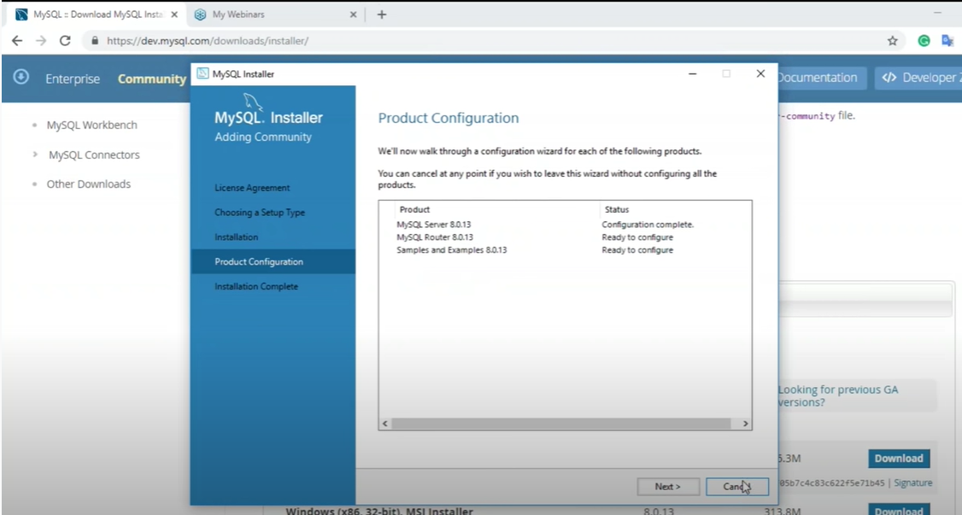

**STEP: - 15**

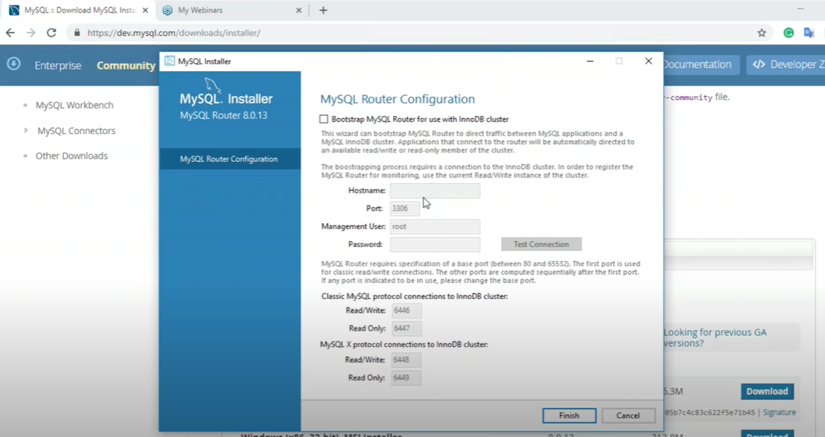

**STEP: - 16**

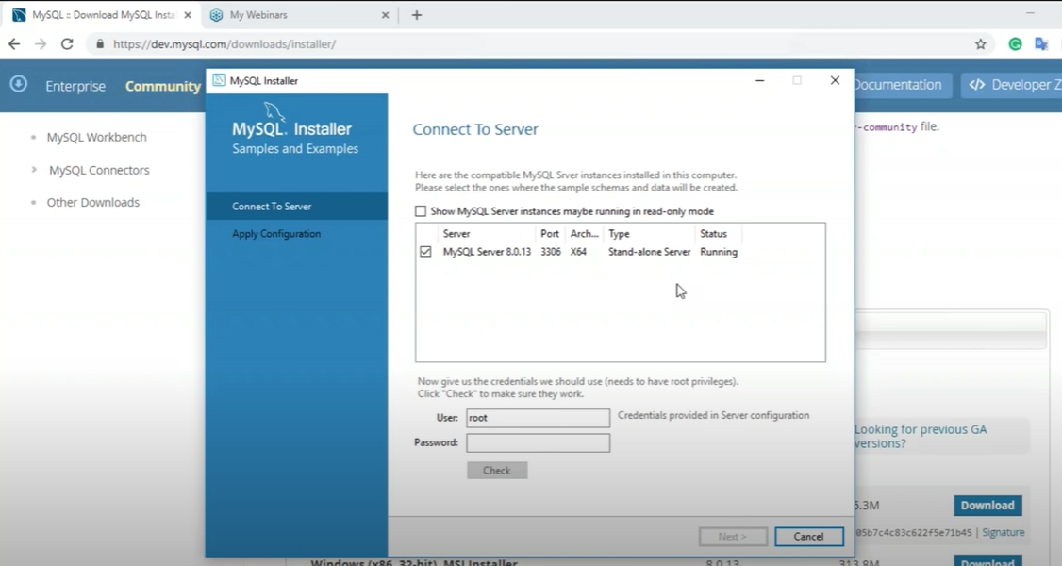

**STEP: - 17**

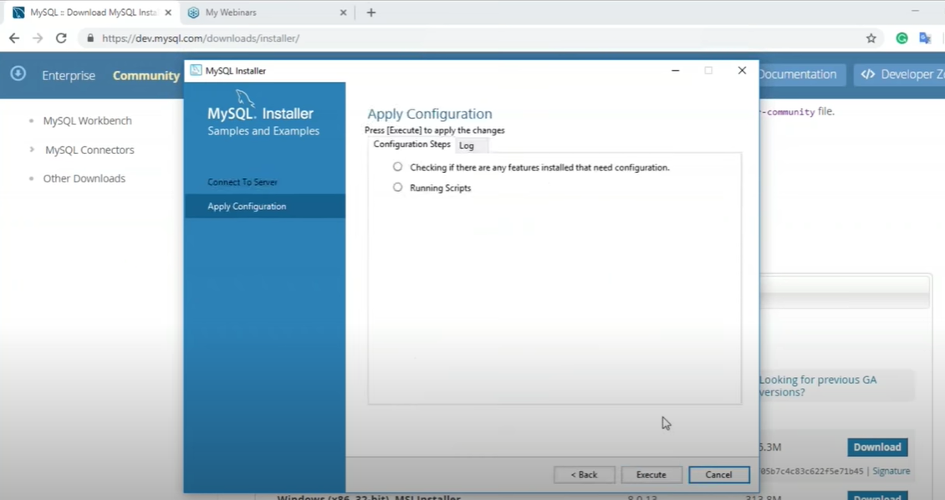

**STEP: - 18**

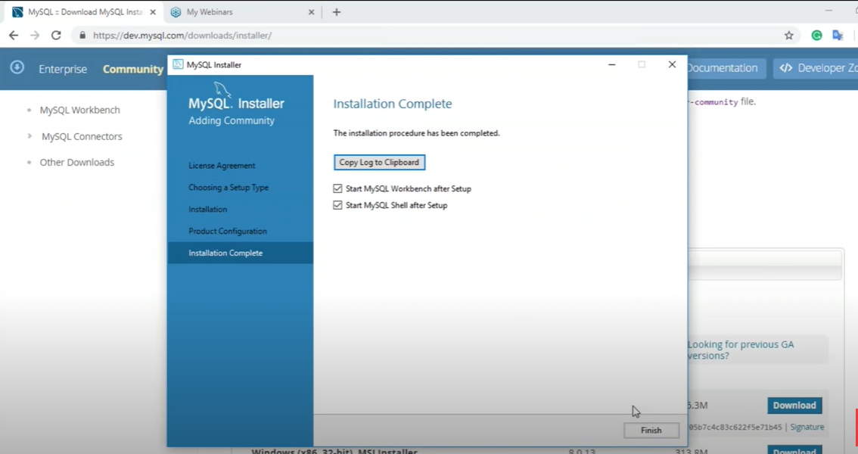

**STEP: - 19**

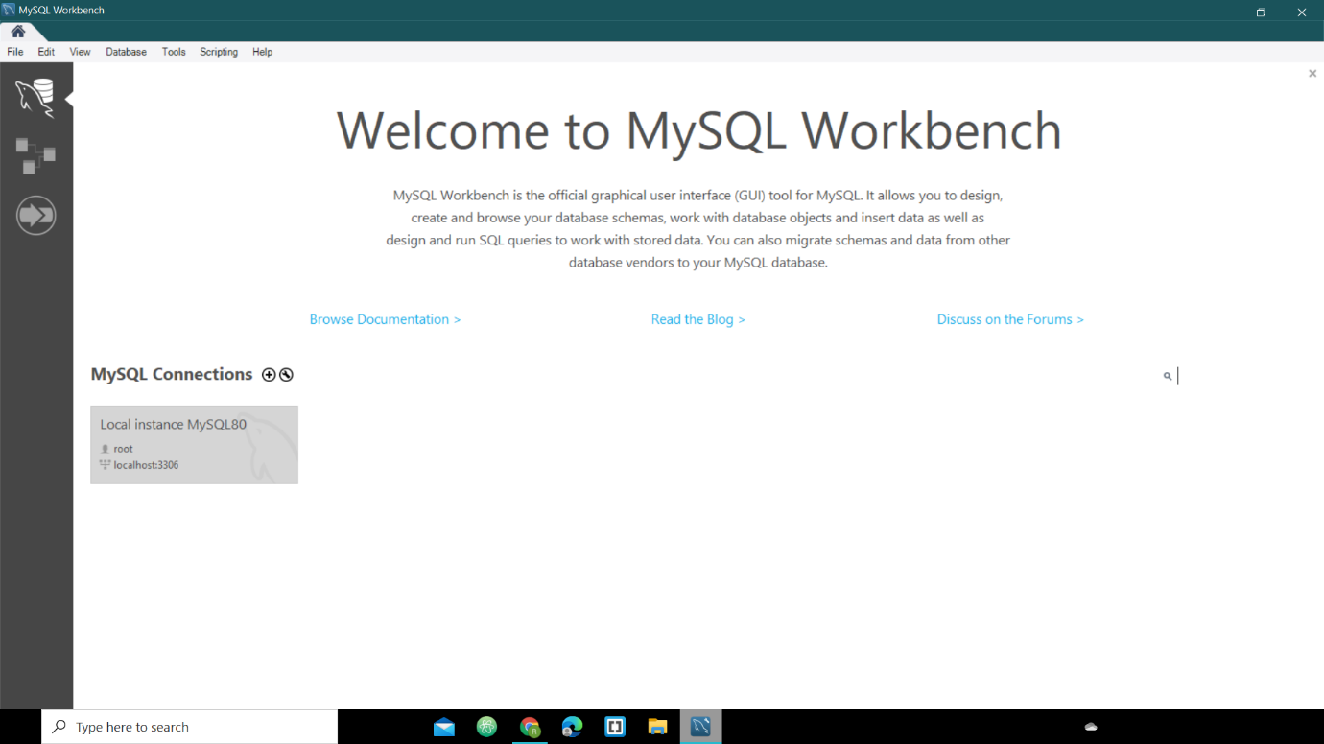

**STEP: - 20**

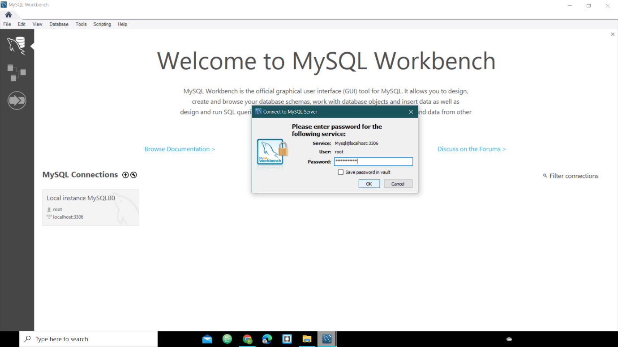

**STEP: - 21**

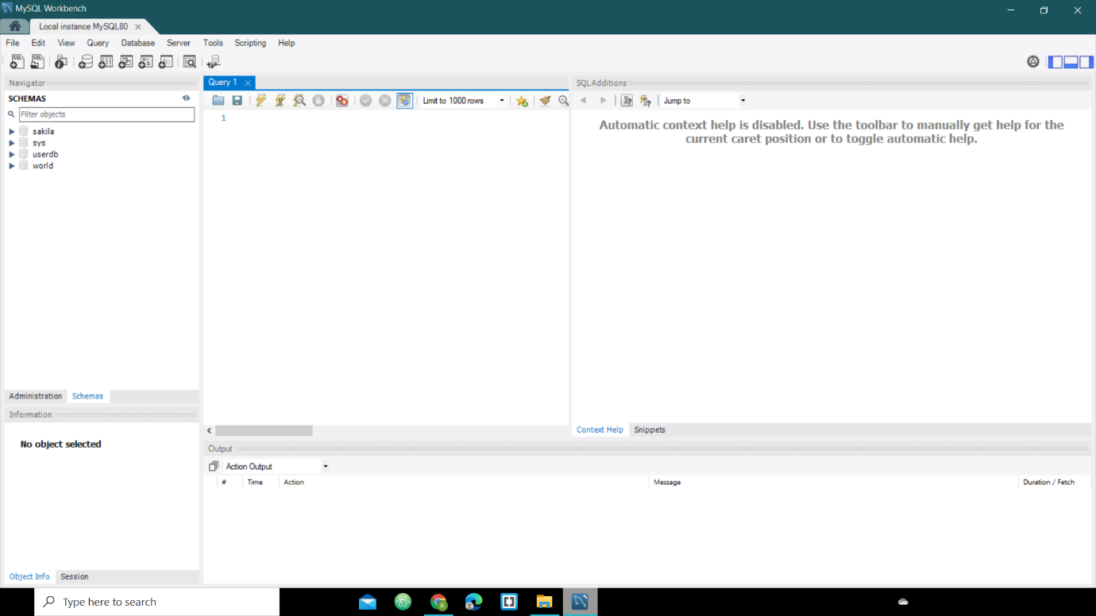

**Assignment – 4**

**19BIT076 (Meet Sheladiya)**

1. **Selection**

Query:

SELECT * FROM card_details WHERE amount>1500

Description:

The above query will select rows from card_details table where amount is greater than 1500

1. **Projection**

Query:

SELECT booking_id, seat_number FROM confirmation

Description:

The above query will select columns booking_id and seat_number from confirmation table

1. **Cartesian Product**

Query:

SELECT payment_method.booking_id, card_details.amount

FROM

payment_method, card_details

Description:

The above query will select columns booking_id and amount from the tables payment_method and card_details respectively and join them.

1. **Union**

Query:

SELECT audience_id, seat_number FROM seat_details

UNION

SELECT audience_id, ROUND (temperature) FROM audience_temperature

Description:

The above query will select columns from respective tables and display unique data and display the common data present in both tables only once.

1. **Set Difference**

Query:

SELECT audience_id, seat_number FROM seat_details

MINUS

SELECT audience_id, ROUND (temperature) FROM audience_temperature

Description:

The above query will select columns from respective tables and display unique data from columns of seat_details table which is not present in columns of audience_temperature table.

1. **Natural Join**

Query:

SELECT * FROM payment_method

NATURAL JOIN

card_details

Description:

The above query will display the common columns from the tables only once.

1. **Composition of any two form (1-6) operators**

Query:

SELECT * FROM payment_method

NATURAL JOIN

card_details

Description:

The above query uses the composition of two operators SELECT and NATURAL JOIN.

1. **Composition of any three form (1-6) operators**

Query:

SELECT * FROM payment_method

NATURAL JOIN

card_details

UNION

confirmation

Description:

The above query uses the composition of three operators SELECT, NATURAL JOIN and UNION. Firstly, the columns of the two tables payment_method and card_details will be Natural Joined and then we will Union them with confirmation table.

**19BIT108(Renish Jagani)**

* **Selection:-**

**Query:-**

SELECT * FROM venue WHERE city_id =21;

**Description**

The above query will select rows from table venue where city_id is 21.

* **Projection:-**

**Query:-**

SELECT match_number, match_id from fixtures;

**Description**

The above query will select columns match_number and match_id from fixtures.

* **Cartesian Product:-**

**Query:-**

SELECT home_team. home_team_ID, away_team. name, away_team. away_team_id

FROM home_team, away_team;

**Description:**  The above query will display all the selected columns from tables home_team, away_team

* **Union**

**Query:-**

SELECT match_number,stadium_id FROM fixtures

UNION

seat_number, stadium_id FROM conformation;

**Description: -** The above query will display only unique data from the selected attributes from respected tables.

* **Set Difference:-**

**Query:-**

SELECT match_number, stadium_id FROM fixtures

MINUS

SELECT seat_number, stadium_id FROM conformation;

**Description: -** The above query will subtract the common data and display the attributes of fixtures which are not present in conformation.

* **Natural Joint:-**

**Query:-**

SELECT * FROM

venue NATURAL JOIN fixtures;

**Description:** The columns with the same name of associated tables will appear once only.

* **Composition of any two from (1-6) operators**

**Query:-**

SELECT * FROM

fixtures NATURAL JOIN conformation

**Description:** The above query uses the composition of two operators SELECT AND NATURAL JOIN.

* **Composition of any three of above from (1-6) operators**

SELECT * FROM

fixtures NATURAL JOIN conformation

UNION

venue

**Description**:The above query uses the composition of three operators SELECT, NATURAL JOIN and union. Firstly, the attributes of two tables fixtures and conformation will be Natural Joined and all the duplicate values of common attribute will be eliminated and then we will union it with venue table.

**19BIT109(Risht Samariya)**

* **Selection:-**

**Query:**

SELECT * FROM food name WHERE MRP=Rs 100

**Description-** Selection will select tuples from table food_and_beverages where the food name mrp is Rs100

* **Projection:-**

**Query:**

SELECT food_id, seat_number from food_and_beverages_order

**Description**- Projection will select the column of food_id and seat_number from table food_and _beverages_order

* **Cartesian Product:-**

**Query:**

SELECT jersy. jersy_id, jersy_order. booking_id FROM jersy, jersy_order

**Description**- It will merge jersy_id and seat_number from jersy table to booking_id from jersy_order table

* **Union:-**

**Query:**

SELECT seat_number from food_and_beverages

UNION

SELECT seat_number from jersy

**Description**- Union will merge the seat_number of table food_and_beverages with seat_number of table jersy which will show only unique data which is not common in both column.

* **Set difference:-**

**Query:**

SELECT booking_id from food_and_beverages_order

MINUS

SELECT booking_id from jersy_order

**Description**- It will subtract the common data from booking_id of both table food_and_beverages_order and jersy_order and it will display it.

* **Natural Join:--**

**Query:-**

SELECT*FROM food_and_beverages NATURAL JOIN jersy

**Description**- The columns of seat_number and MRP in both table will only appear once in the output because it is common in both the table.

* **Composition of any two from (1-6) operators Query:-**

**Query:-**

SELECT booking_id from food_and_beverages

UNION

SELECT booking_id from jersy

**Description**- there is two operation composition projection and union

* **Composition of any three of above from (1-6) operators Query:-**

**Query:-**

SELECT * FROM

food_and_beverages NATURAL JOIN jersy

UNION

Food_and_beverages_order

**Description**- there is three operation composition projection (select), Natural Join and Union

**19BIT141(Rishabh Patel)**

1. **Select Operation**

Query: - SELECT * FROM seat_booking WHERE seat_number >= 45

Description – In Select operation, we are selecting seat_number attribute from seat_booking and having constraint that seat_number must be greater than greater 45.

1. **Projection**

Query: - SELECT username, password FROM login

Description – In above projection operation we select username and password from login table and output both table.

1. **Cartesian Product**

Query: - SELECT login. email_id, login. username, seat_booking. seat_number

FROM login, seat_booking

Description – In Cartesian product is selecting email_id and seat_number from login and seat_number from seat_booking and displaying all three attributes as an output.

1. **Union**

Query: - SELECT email_id, age FROM login

UNION

SELECT email_id, seat_number FROM seat_booking

Description – In Union Operation it includes email_id, age from login and email_id, seat_number from seat_booking and it eliminates duplicate tuples.

1. **Set Difference**

Query: - SELECT email_id, age FROM login

MINUS

SELECT email_id, seat_number FROM seat_booking

Description – The output of set difference (A-B), is removing common values of age and seat_number and display only unique data from the login table.

1. **Natural Join**

Query: - SELECT * FROM login NATURAL JOIN seat_booking

Description – In Natural Join, displaying the attributes only once which are present in both

The tables and uncommon as it is.

1. **Composition of any two from (1-6)operations**

Query: - SELECT login.email_id, login.username, seat_booking.audience_id

FROM login, seat_booking

UNION

SELECT audience_id, gate_number, tier FROM seat_arrangement

Description: - In this above query, there are composition of two operations **Cartesian product** and **Union** operator firstly selecting name, phone_number seat_number attributes from seat_booking table and section from seat_location and cross joining two tables and finally talking union with gate_number which results in displaying all values of respective attributes only once.

1. **Composition of any three from (1-6)operations**

Query: - ­SELECT email_id, booking_id, audience_id FROM seat_booking

NATURAL JOIN seat_location

UNION

SELECT email_id, phone_number, username FROM login

MINUS

SELECT audience_id FROM seat_arrangement

Description:- In the above query, the Composition of three operators are **Natural Join, Union** and **Set Difference** first we select all attributes from seat_booking and seat_location tables and perform natural join so we get all unique columns and common columns only once then taking union with email_id and phone_number attribute from login input table so we include both attribute in our output then finally set difference with audience_id attribute from seat_arrangement so final output is that we will get all the attributes except of audience_id attribute because we minus it from previous output table.

**19BIT142(Ujash Thakkar)**

1. **Selection Operation**

**QUERY:**

SELECT tuples FORM match_details WHERE match_number =15.

**Description:**

The above query will select rows form table match_details where match_number is 15.

1. **Projection**

**QUERY:**

SELECT seat_number and booking_id FORM audience_verification.

**Description:**

In above query will select seat_number and booking_id from audience_verification.

1. **Cartesian Product**

**QUERY:**

SELECT booking_id, match_number, audience_id FORM audience_verification, tickets_cancelled.

**Description:**

In above query Cartesian product is selecting booking_id, audience_id form audience_verification and match _number from tickets_cancelled.

1. **Union**

**QUERY:**

SELECT stadium_id, audience_id, match_number FORM match_details.

UNION

SELECT stadium_id, stadium_number FORM stadium_details.

**Description:**

In Union Operation in includes stadium_id, audience_id, match_number FORM match_details and stadium_id, stadium_number FORM stadium_details and it eliminates supplicate tuples.

1. **Set Difference**

**QUERY:**

SELECT stadium_id, audience_id, match_number FORM match_details.

MINUS

SELECT stadium_id, stadium_number FORM stadium_details.

**Description:**

The above query will subtract the common data and display the unique data.

1. **Natural Join**

**QUERY:**

SELECT *FROM tickets_cancelled NATURAL JOIN audience_verification.

**Description:**

In above query natural join, print the attributes only once which are not present in both tables and uncommon as it is.

1. **Composition of any two from (1-6) operators**

**QUERY:**

SELECT seat_number

FROM audience_verification

NATURAL JOIN tickets_cancelled

**Description:** The above query uses the composition of two operators SELECT AND NATURAL JOIN.

1. **Composition of any three of above from (1-6) operators**

**QUERY:**

SELECT seat_number

FROM audience_verification.

NATURAL JOIN tickets_cancelled

UNION match_detail

**Description:** The above query uses the composition of 3 operators SELECT, UNION AND NATURAL JOIN.

**19BIT144(Ananya Khandelwal)**

1. **Selection** – SELECT * FROM tickets_sold where sold >= 500.

**Description** – Selection will select tuples from table tickets sold where the tickets sold are more than 500.

1. **Projection** – SELECT brand_name, cost from advertisement.

**Description** – Projection will select the column of brand_name and cost from table advertisement.

1. **Cartesian product** - SELECT tickets_sold. stadium_id, tickets_sold. sold, tickets_available. available

FROM tickets_sold, tickets_available.

**Description** – Cartesian product will merge stadium_id, sold and available from tables ticekts_sold and tickets_available respectively.

1. **Union** – Select match_number, sold from tickets sold

UNION

select match_number, available from tickets available.

**Description** – Union will display only unique data from the selected attributes which is not common in both the tables.

1. **Set Difference** - Select match_number, sold from tickets sold

MINUS

select match_number, available from tickets_available.

**Description** – Set difference will subtract the common data and display the attributes of tickets sold which are not present in tickets available.

1. **Natural Join** – SELECT * FROM

tickets_sold

NATURAL JOIN

weather.

**Description** – The columns with same name in both the tables will appear only once in the output.

1. **Composition of Two Operators** – SELECT * FROM

Weather NATURAL JOIN tickets_available

**Description** – This query will composite two individual operators i.e., SELECT & NATURAL JOIN.

1. **Composition of Three Operators** – SELECT * FROM

Weather NATURAL JOIN tickets_available.

UNION

tickets_sold.

**Description** – This query will composite three individual operators i.e., SELECT, NATURAL JOIN, UNION.

**Assignment-6**

**19BIT076 (Meet Sheladiya)**

1. **payment_method**

CREATE TABLE `payment_method` (

`booking_id` varchar (255),

`match_id` varchar (255),

`payment_mode` varchar (255),

`payment_id` varchar (255) PRIMARY KEY AUTO_INCREMENT,

`amount` int DEFAULT NULL

);

1. **card_details**

CREATE TABLE `card_details` (

`payment_id` varchar (255) PRIMARY KEY AUTO_INCREMENT,

`card_number` varchar (255),

`amount` int DEFAULT NULL,

`expiry_date` varchar (255)

);

1. **confirmation**

CREATE TABLE `confirmation` (

`booking_id` varchar (255),

`stadium_id` varchar (255),

`match_id` varchar (255),

`seat_number` int DEFAULT NULL PRIMARY KEY AUTO_INCREMENT

);

1. **audience_temperature**

CREATE TABLE `audience_temperature` (

`audience_id` varchar (255) PRIMARY KEY AUTO_INCREMENT,

`temperature` double DEFAULT NULL

)

**19BIT108(Renish Jagani)**

* CREATE TABLE ‘venue(

‘city_id’ int,

‘name’ varchar (255),

‘stadium_id’ varchar (255) PRIMARY KEY AUTO_INCREMENT,

);

* CREATE TABLE ‘fixtures’ (

‘match_number’ int PRIMARY KEY AUTO_INCREMENT,

‘match_id’ varchar (255),

‘stadium_id’ varchar (255),

‘home_team_id’ varchar (255),

‘away_team_id’ varchar (255),

‘city_id’ int,

);

* CREATE TABLE ‘home_team_id’ (

‘home_team_id’ varchar (255) PRIMARY KEY AUTO_INCREMENT,

‘name’ varchar (255),

‘home_stadium’ varchar (255),

);

* CREATE TABLE ‘away_team_id’ (

‘away_team_id’ varchar (255) PRIMARY KEY AUTO_INCREMENT,

‘name’ varchar(255),

)

**19BIT109(Rishit Samariya)**

* CREATE TABLE ‘food_and_beverages’(

‘seat_number’ int PRIMARY KEY AUTO_INCREMENT,

‘food_id’ varchar (255),

‘food_name’ varchar (255),

‘MRP’ int,

);

* CREATE TABLE ‘food_and_beverages_order’(

‘seat_number’ int PRIMARY KEY AUTO_INCREMENT,

‘food_id’ varchar (255),

‘booking_id’ varchar (255),

);

* CREATE TABLE ‘jersy’(

‘seat_number’ int PRIMARY KEY AUTO_INCREMENT

‘jersy_id’ varchar (255),

‘team_name’ varchar (255),

‘size’ int,

‘MRP’ int,

);

* CREATE TABLE ‘jersy_order’(

‘seat_number’ int PRIMARY KEY AUTO_INCREMENT

‘jersy_id’ varchar (255),

‘booking_id’ varchar (255),

);

**19BIT141(Rishabh Patel)**

* **Login:-**

CREATE TABLE `stadium_seat_booking_database`. `login` (

`email_id` VARCHAR (45) NOT NULL,

`username` VARCHAR (245) NOT NULL,

`password` VARCHAR (245) NOT NULL,

`f_name` VARCHAR (245) NOT NULL,

`l_name` VARCHAR (245) NOT NULL,

`gender` VARCHAR (245) NOT NULL,

`age` INT NOT NULL,

`phone_number` INT (10) NOT NULL,

`security_question` VARCHAR (245) NOT NULL,

`answer` VARCHAR (245) NOT NULL,

PRIMARY KEY (`email_id`, `username`, `password`));

* **Seat_booking:-**

CREATE TABLE `stadium_seat_booking_database`.`seat_booking` (

`booking_id` VARCHAR (245) NOT NULL,

`email_id` VARCHAR (245) NOT NULL,

`name` VARCHAR (245) NOT NULL,

`phone_number` INT (10) NOT NULL,

`address` VARCHAR (245) NOT NULL,

`postal_code` INT (10) NOT NULL,

`seat_number` INT (10) NOT NULL,

`audience_id` VARCHAR (245) NOT NULL,

`match_id` VARCHAR (245) NOT NULL,

PRIMARY KEY (`booking_id`, `phone_number`, `seat_number`, `audience_id`, `match_id`));

* **Seat arrangement:-**

CREATE TABLE `stadium_seat_booking_database`.`seat_arrangement` (

`audience_id` VARCHAR (245) NOT NULL,

`gate_number` INT (10) NOT NULL,

`tier` INT (10) NOT NULL,

`stadium_id` VARCHAR (245) NOT NULL,

PRIMARY KEY (`audience_id`));

* **Seat Location:-**

CREATE TABLE `stadium_seat_booking_database`.`seat_location` (

`seat_number` INT (10) NOT NULL,

`section` VARCHAR (245) NOT NULL,

PRIMARY KEY (`seat_number`));

* **Seat Details:-**

CREATE TABLE `stadium_seat_booking_database`.`seat_details` (

`booking_id` VARCHAR (245) NOT NULL,

`audience_id` VARCHAR (245) NOT NULL,

`match_id` VARCHAR (245) NOT NULL,

`seat_number` INT (10) NOT NULL,

`seat_category` VARCHAR (245) NOT NULL,

`price` DOUBLE (10) NOT NULL,

PRIMARY KEY (`booking_id`, `audience_id`, `seat_number`));

**19BIT142(Ujash Thakkar)**

1. audience_verification

CREATE TABLE’ audience_verification` (

‘booking_id’ varchar (255),

‘audience_id’ varchar (255), PRIMARY KEY AUTO_INCREMENT

‘phone_number’ int (10),

‘seat_number’ int (10), PRIMARY KEY AUTO_INCREMENT

‘aadhar_number’ int (12),

PRIMARY KEY (`booking_id’, ‘phone_number’, ‘aadhar_number’));

1. ticket_cancelled

CREATE TABLE` ticket_cancelled ‘(

‘stadium_id` varchar (255),

‘match_id` varchar (255),

‘match_number’ int DEFAULT NULL, PRIMARY KEY AUTO_INCREMENT

‘audience_id’ varchar (255), PRIMARY KEY AUTO_INCREMENT

1. stadium_details

CREATE TABLE ‘stadium_details’ (

‘stadium_id’ varchar (255), PRIMARY KEY AUTO_INCREMENT

‘stadium_name’ varchar (255),

‘address’ varchar (255),

‘capacity’ int,

1. match_details

CREATE TABLE ‘match_details’ (

‘stadium_id’ varchar (255),

‘audience_id’ varchar (255), PRIMARY KEY AUTO_INCREMENT

‘match_number’ INT DEFAULT NULL, PRIMARY KEY AUTO_INCREMENT

‘match_id` varchar (255),

‘date_of_match’ varchar (255),

‘match_timing’ varchar (255),

**19BIT144(Ananya Khandelwal)**

1. CREATE TABLE `tickets_sold` (

`Stadium_id` varchar (255),

`Match_id` varchar (255),

`Match_number` int DEFAULT NULL, PRIMARY KEY AUTO_INCREMENT

`Sold` int DEFAULT NULL

);

1. CREATE TABLE `advertisement` (

`Audience_id` varchar (255), PRIMARY KEY AUTO_INCREMENT

`Brand_name` varchar (255),

`Cost (In Rs) ` double DEFAULT NULL

);

1. TABLE `weather` (

`Match_Number` int DEFAULT NULL, PRIMARY KEY AUTO_INCREMENT

`Temperature (Celsius) ` double DEFAULT NULL,

`Humidity (%) ` int DEFAULT NULL

;

1. CREATE TABLE `tickets_available` (

`Stadium_id` varchar (255),

`Match_id` varchar (255),

`Match_number` int DEFAULT NULL, PRIMARY KEY AUTO_INCREMENT

`Available` int DEFAULT NULL

)

**Assignment – 7**

**19BIT076 (Meet Sheladiya)**

1. **Aggregate functions**

**Max**

Query:

SELECT MAX (temperature) FROM audience_temperature

1. **Numeric**

Query:

SELECT ROUND (temperature) FROM audience_temperature

1. **Date**

Query:

SELECT * FROM card_details WHERE expiry_date=’2023-05-27’

1. **String function**

Query:

SELECT LENGTH (payment_mode) FROM payment_method

**19BIT108 (Renish Jagani)**

* **Aggregate function:-**

SELECT COUNT (city_id) FROM venue;

* **Built-in Numeric Function:-**

SELECT MAX (humidity) FROM weather;

* **String Functions:-**

SELECT name, ASCII (name)

FROM home_team;

* **Date Function:-**

SELECT YEAR ('2017/08/25');

**19BIT109 (Rishit Samariya)**

* **Aggregate function-**

**Query:-**

SELECT MAX (MRP) FROM food_and_beverages;

* **Built-in Numeric Function-**

**Query:-**

SELECT ABS (Size) FROM Jersy;

* **String Function-**

**Query:-**

Select food_name, UPPER (food_name) from food_and_beverages

* **Date Function-**

**Query:-**

SELECT * FROM card_details WHERE expiry_date=’2025-01-02’

**19BIT141 (Rishabh Patel)**

1. **Aggregate function:-**

SELECT SUM (age) FROM login;

1. **Built-in Numeric Function:-**

SELECT ROUND (price) FROM seat_details;

1. **String Function:-**

SELECT CONCAT (f_name, l_name) FROM login;

1. **Date Function:-**

SELECT * FROM card_details WHERE expiry_date = ‘2023-24-11’

**19BIT142(Ujash Thakkar)**

1. **Aggregate function**

**Query:**

SELECT COUNT (audience_id) FROM ticket_cancelled

1. **Numeric function**

**Query:**

SELECT ABS (seat_number) FROM audience_verification

1. **Date function**

**Query:**

SELECT date_of_match FROM match_details WHERE

date_of_match=’2021-04-03’;

1. **String function**

**Query:**

SELECT stadium_name, LOWER (stadium_name) FROM stadium_details

**19BIT144 (Ananya Khandelwal)**

1. **Aggregate Function:-**

SELECT avg (cost) FROM advertisement.

1. **Built in Numeric function:-**

SELECT ROUND (temperature) FROM weather where match number = 2.

1. **Date:-**

SELECT YEAR (‘2019/0510’)

1. **String:-**

SELECT length (brand_name) FROM advertisement where audience id = _________.

**Assignment-8**

**19BIT076 (Meet Sheladiya)**

1. **Set Operations**
2. **Union**

Query:

SELECT audience_id, seat_number FROM seat_details

UNION

SELECT audience_id, ROUND (temperature) FROM audience_temperature

1. **Union All**

Query:

SELECT audience_id, seat_number FROM seat_details

UNION ALL

SELECT audience_id, ROUND (temperature) FROM audience_temperature

1. **Intersect**

Query:

SELECT audience_id, seat_number FROM seat_details

INTERSECT

SELECT audience_id, ROUND (temperature) FROM audience_temperature

1. **Minus**

Query:

SELECT audience_id, seat_number FROM seat_details

MINUS

SELECT audience_id, ROUND (temperature) FROM audience_temperature

1. **Sub-queries**

Query:

SELECT * FROM audience_temperature WHERE temperature>37

1. **Correlated sub-queries**

Query:

SELECT booking_id, match_id, amount

FROM payment_method

WHERE payment_id = (SELECT payment_id FROM card_details WHERE amount>4900)

**19BIT108 (Renish Jagani)**

* **Set operations:-**

SELECT match_number, stadium_id FROM fixtures

UNION

seat_number, stadium_id FROM conformation;

* **Sub queries:-**

SELECT *

FROM fixtures

WHERE match_id IN (SELECT match_id

FROM fixtures

WHERE city_id > 20);

* **Co-related Sub queries:-**

SELECT match_id from fixtures where stadium_id= (SELECT STADIUM_ID FROM VENUE WHERE city_id>6)

**19BIT109 (Rishit Samariya)**

1. **Set Operations:-**

* **Union-**

**Query:-**

SELECT seat_number from food_and_beverages

UNION

SELECT seat_number from jersy

* **Union All-**

**Query:-**

SELECT seat_number from food_and_beverages

UNION All

SELECT seat_number from jersy

* **Intersect-**

**Query:-**

SELECT seat_number from food_and_beverages

INTERSECT

SELECT seat_number from jersy

* **Minus-**

**Query:-**

SELECT booking_id from food_and_beverages_order

MINUS

SELECT booking_id from jersy_order

1. **Sub-queries:-**

**Query:-**

SELECT * FROM food name WHERE MRP=Rs 100

1. **Correlated sub-queries:-**

**Query:-**

SELECT food_name, seat_number,

FROM food_and_beverages

WHERE food_id = (SELECT food_id FROM food_and_beverages_order WHERE seat_number = 10)

**19BIT141 (Rishabh Patel)**

1. **Set Operations:-**

* **INTERSECT:-**

**Query:-**

SELECT email_id, username, password FROM login

INTERSECT

SELECT email_id, name, phone_number FROM seat_booking;

* **UNION:-**

**Query:-**

SELECT email_id, age FROM login

UNION

SELECT email_id, seat_number FROM seat_booking;

* **UNION ALL:-**

**Query:-**

SELECT * FROM seat_booking

UNION ALL

SELECT * FROM seat_arrangement;

* **MINUS:-**

**Query:-**

SELECT audience_id, name, seat_number FROM seat_booking

MINUS

SELECT audience_id, gate_number, tier;

1. **Sub-Queries:-**

* **UPDATE:-**

**Query:-**

UPDATE seat_details

SET price = price * 0.5

WHERE 4 >= (SELECT COUNT (match_id) FROM seat_booking

WHERE seat_booking.seat_number = seat_details.seat_number)

1. **Correlated Sub-Queries:-**

**Query:-**

SELECT name, email_id, seat_number

FROM seat_booking

WHERE booking_id = (SELECT booking_id FROM seat_details

WHERE audience_id = ‘A-011’);

**19BIT142(Ujash Thakkar)**

1. **Set Operations**

**Union**

**QUERY:**

SELECT stadium_id, audience_id, match_number FORM match_details.

UNION

SELECT stadium_id, stadium_number FORM stadium_details.

1. **Sub-queries**

**QUERY:** SELECT * FROM audience_temperature WHERE temperature>37

1. **Correlated sub-queries**

**QUERY:**

SELECT stadium_id, stadium_name, FROM stadium_details

WHERE match_id = (SELECT match_id FROM match_details

WHERE match_number>23)

**19BIT144 (Ananya Khandelwal)**

1. **Set Operations:-**

SELECT * FROM weather

INTERSECT

SELECT * FROM tickets_available.

1. **Sub Queries:-**

SELECT * FROM advertisement WHERE audience_id IN (SELECT audience_id FROM advertisement WHERE cost > 100000)

1. **Correlated Sub Queries:-**

SELECT stadium_id,match_id FROM tickets_available

WHERE match_number=(SELECT match_number FROM tickets_sold WHERE sold>4900)

**Assignment-9**

**19BIT076 (Meet Sheladiya)**

1. **Group By;-**

Query:-

SELECT payment_mode, SUM (amount) FROM payment_method

GROUP BY payment_mode

1. **Having;-**

Query:-

SELECT stadium_id, COUNT (booking_id) FROM confirmation

GROUP BY stadium_id

HAVING COUNT (booking_id)>1

1. **Order By;-**

Query:-

SELECT * FROM card_details

ORDER BY amount

**19BIT108 (Renish Jagani)**

* **Group By:-**

SELECT COUNT (stadium_id), name  
FROM venue  
GROUP BY name;

* **Having:-**

SELECT COUNT (stadium_id), name  
FROM venue  
GROUP BY name

HAVING COUNT (stadium_id)> 1

(RETURNS ONLY CITY THAT HAS MORE THAN ONE STADIUM)

* **Order By:-**

SELECT * FROM fixtures ORDER BY city_id;

**19BIT109 (Rishit Samariya)**

* **Group By-**

**Query:-**

SELECT food_name, AVG (MRP) FROM food_and_beverages

GROUP BY food_name;

* **ORDER BY-**

**Query:-**

SELECT * FROM food_and_beverages ORDER BY MRP DESC;

* **HAVING-**

**Query:-**

SELECT COUNT (MRP), food_name FROM food_and_beverages

GROUP BY food_name

HAVING COUNT (MRP)>=50;

**19BIT141 (Rishabh Patel)**

1. **Group By:-**

**Query:-**

SELECT security_question, COUNT (email_id) FROM login

GROUP BY security_question;

1. **Having:-**

**Query:-**

SELECT COUNT (email_id), age FROM login

GROUP BY age

HAVING COUNT (email_id) >= 8;

1. **ORDER BY:-**

**Query:-**

SELECT COUNT (name), address FROM seat_booking

GROUP BY address

ORDER BY COUNT (name) DESC;

**19BIT142(Ujash Thakkar)**

1. **Group By**

Query:

SELECT stadium_name, stadium_id

FROM stadium_details

GROUP BY stadium_name;

1. **Having**

Query:

SELECT stadium_name, stadium_id

FROM stadium_details

GROUP BY stadium_name

HAVING COUNT (*) < 8;

1. **Order By**

Query:

SELECT *

FROM match_details

ORDER BY date_of_match;

**19BIT144 (Ananya Khandelwal)**

1. **Group by:-**

SELECT humidity, count (match_number) FROM weather

GROUP BY humidity.

1. **Having:-**

SELECT stadium_id, match_id, match_number FROM tickets_available

GROUP BY available

HAVING available>500.

1. **Order by:-**

SELECT * FROM weather

ORDER by temperature

**Assignment – 10**

**19BIT076 (Meet Sheladiya)**

1. **Join**
2. **Inner Join**

Query:-

SELECT card_details.amount, payment_method.booking_id, payment_method.match_id FROM payment_method

INNER JOIN card_details

ON payment_method. payment_id=card_details.payment_id

1. **Left Join**

Query:-

SELECT card_details.amount, payment_method.booking_id, payment_method.match_id FROM payment_method

LEFT JOIN card_details

ON payment_method.payment_id=card_details.payment_id

1. **Right Join**

Query:-

SELECT card_details.amount, payment_method.booking_id, payment_method.match_id FROM payment_method

RIGHT JOIN card_details

ON payment_method.payment_id=card_details.payment_id

1. **Full Join**

Query:-

SELECT card_details.amount, payment_method.booking_id, payment_method.match_id FROM payment_method

FULL JOIN card_details

ON payment_method.payment_id=card_details.payment_id

1. **Exists**

Query:-

SELECT booking_id, match_id

FROM payment_method

WHERE EXISTS (SELECT * FROM card_details WHERE payment_method.payment_id=card_details.payment_id AND amount>2500)

1. **Any**

Query:-

SELECT booking_id

FROM payment_method

WHERE payment_id = ANY (SELECT payment_id FROM card_details WHERE amount<2000)

1. **All**

Query:-

SELECT booking_id

FROM payment_method

WHERE payment_id = ALL (SELECT payment_id FROM card_details WHERE amount>1000)

**19BIT108 (Renish Jagani)**

* **Join operations inner join:-**

SELECT fixtures.match_number, fixtures.match_id,home_team.name

from fixtures

INNER JOIN home_team

ON home_team.home_team_id = fixtures.home_team_id

* **Left join:-**

SELECT fixtures. match number, fixtures.match_id,home_team.name

from fixtures

LEFT JOIN home_team

ON home_team.home_team_id = fixtures.home_team_id

* **Right join:-**

SELECT fixtures.match_number, fixtures.match_id,home_team.name

from fixtures

RIGHT JOIN home_team

ON home_team.home_team_id = fixtures.home_team_id

* **Full join:-**

SELECT fixtures.match_number, fixtures.match_id,home_team.name

from fixtures

FULL JOIN home_team

ON home_team.home_team_id = fixtures.home_team_id

* **Exist:-**

SELECT match_id, match_number from fixtures

WHERE EXISITS (SELECT * FROM away_team WHERE away_team.away_team_id = fixtures.home_team_id)

* **All:-**

SELECT match_id from fixtures where stadium_id= All (SELECT STADIUM_ID FROM VENUE WHERE CITY_ID>6)

* **Any:-**

SELECT match_id from fixtures where stadium_id= Any (SELECT STADIUM_ID FROM VENUE WHERE CITY_ID>6)

**19BIT109 (Rishit Samariya)**

* **INNER JOIN-**

**Query:-**

SELECT Food_and_beverages_order.booking_id, Food_and_beverages.MRP, Food_and_beverages_order.booking_id

FROM food_and_bevearges

INNER JOIN Food_and_beverages_order.

ON food_and_beverages.seat_number = food_and_beverages_order.seat_number;

* **Left Join-**

**Query:-**

SELECT jersy_order.booking_id, jersy.team_name

FROM jersy_order

LEFT JOIN jersy

ON jersy.seat_number =jersy_order.seat_number;

* **Right Join-**

**Query:-**

SELECT Food_and_beverages_order.booking_id, Food_and_beverages.booking_id

FROM food_and_bevearges

RIGHT JOIN Food_and_beverages_order.

ON food_and_beverages.seat_number = food_and_beverages_order.seat_number;

* **FULL JOIN-**

**Query:-**

SELECT Food_and_beverages_order.booking_id, Food_and_beverages.booking_id

FROM food_and_bevearges

FULL JOIN Food_and_beverages_order.

ON food_and_beverages.seat_number = food_and_beverages_order.seat_number;

* **EXISTS-**

**Query:-**

SELECT food_id from food_and_beverages_order

WHERE EXISTS (SELECT * FROM jersy_order

WHERE food_and_beverages_order.seat_number = jersy_order.seat_number)

* **All-**

**Query:-**

SELECT food_name

FROM food_and_beverages

WHERE food_id = ALL (SELECT food_id FROM food_and_beverages_order WHERE seat_number = 10)

* **ANY-**

**Query:-**

SELECT food_name

FROM food_and_beverages

WHERE food_id = ANY (SELECT food_id FROM food_and_beverages_order WHERE seat_number = 10)

**19BIT141 (Rishabh Patel)**

* **Join Operations:-**

1. **INNER JOIN:-**

**Query:-**

SELECT seat_arrangement. gate_number, seat_details. match_id, seat_details. seat_number FROM seat_details

INNER JOIN seat_arrangement

ON seat_details. audience_id = seat_arrangement. audience_id;

1. **LEFT JOIN:-**

**Query:-**

SELECT seat_arrangement. gate_number, seat_details. match_id, seat_details. seat_number FROM seat_details

LEFT JOIN seat_arrangement

ON seat_details. audience_id = seat_arrangement. audience_id;

1. **RIGHT JOIN:-**

**Query:-**

SELECT seat_arrangement. gate_number, seat_details. match_id, seat_details. seat_number FROM seat_details

RIGHT JOIN seat_arrangement

ON seat_details. audience_id = seat_arrangement. audience_id;

1. **FULL JOIN:-**

**Query:-**

SELECT seat_arrangement. gate_number, seat_details. match_id, seat_details. seat_number FROM seat_details

FULL JOIN seat_arrangement

ON seat_details. audience_id = seat_arrangement. audience_id;

* **Exists:-**

**Query:-**

SELECT f_name, l_name FROM login

WHERE EXISTS (SELECT * FROM seat_booking

WHERE login. email_id = seat_booking. Email_id AND age>=25)

* **Any:-**

**Query:-**

SELECT name

FROM seat_booking

WHERE audience_id = ANY (SELECT audience_id FROM seat_arrangement

WHERE gate_number = 2 OR gate_number = 4)

* **ALL:-**

**Query:-**

SELECT name

FROM seat_booking

WHERE audience_id = ALL (SELECT audience_id FROM seat_arrangement

WHERE gate_number = 2 OR gate_number = 4);

**19BIT142(Ujash Thakkar)**

1. **Inner Join**

**Query:**

**SELECT** audience_verification. phone number, match_details. match_number, match_details. match_timing FROM match_details

**INNER JOIN** audience_verification

**ON** match_details. audience_id = audience_verification. audience_id;

1. **Left Join**

**Query:**

**SELECT** audience_verification. phone number, match_details. match_number, match_details. match_timing FROM match_details

**LEFT JOIN** audience_verification

**ON** match_details. audience_id = audience_verification. audience_id;

1. **Right join**

**Query:**

**SELECT** audience_verification. phone number, match_details. match_number, match_details. match_timing FROM match_details

**RIGHT JOIN** audience_verification

**ON** match_details. audience_id = audience_verification. audience_id;

1. **Full join**

**Query:**

**SELECT** audience_verification. phone number, match_details. match_number, match_details. match_timing FROM match_details

**FULL JOIN** audience_verification

**ON** match_details. audience_id = audience_verification. audience_id;

1. **Exists**

**Query:**

**SELECT** booking_id, seat_number

FROM audience_verification

WHERE **EXISTS** (SELECT * FROM match_details WHERE

audience_verification.audience_id=match_details.audience_id)

1. **Any**

**Query:**

**SELECT** booking_id

FROM audience_verification

WHERE audience_id = (SELECT audience_id FROM ticket_cancelled WHERE seat_number is=564)

1. **All**

**Query:**

**SELECT** booking_id

FROM audience_verification

WHERE audience_id = (SELECT audience_id FROM ticket_cancelled WHERE seat_number is=465)

**19BIT144 (Ananya Khandelwal)**

1. **INNER JOIN**

Query -

SELECT weather.temperature, tickets_available.stadium_id, tickets_available.match_id FROM tickets_available

INNER JOIN weather

ON tickets_available.match_number = weather.match_number

1. **LEFT JOIN**

Query

SELECT weather.temperature, tickets_available.stadium_id, tickets_available.match_id FROM tickets_available

LEFT JOIN weather

ON tickets_available.match_number = weather.match_number

1. **RIGHT JOIN**

Query

SELECT weather.temperature, tickets_available.stadium_id, tickets_available.match_id FROM tickets_available

RIGHT JOIN weather

ON tickets_available.match_number = weather.match_number

1. **FULL JOIN**

Query

SELECT weather.temperature, tickets_available.stadium_id, tickets_available.match_id FROM tickets_available

FULL JOIN weather

ON tickets_available.match_number = weather.match_number

1. **EXIST**

SELECT temperature, humidity FROM weather

WHERE EXISTS (SELECT * FROM tickets_available WHERE weather.match_number=tickets_available.match_number

1. **ALL**

SELECT brand_name FROM advertisement

WHERE match_number=ALL (SELECT match_number FROM tickets_sold WHERE available>500)

1. **ANY**

SELECT sold FROM tickets_sold

WHERE match_number=ANY (SELECT match_number FROM tickets_available WHERE available>4900)